WEALTH INEQUALITY

Paul Hahn, Theology Department
University of St Thomas, Houston TX 77006
© 2027, theologyplus.com

the problem

In 1959, the top 10% of US families owned 32% of US wealth. By 2009, the top 10% owned 50%. Wealth is even more concentrated in the top 1%: “The top 1% holds nearly as much wealth as the bottom 90% . . .”

Worldwide, the top 10% owns 76% of wealth. The bottom 50% owns 1%.

While there are obvious differences between capitalism and slavery (e.g., employees can change employers), one thing they have in common is an inherent tendency toward wealth inequality.

A slave owner reaps 100% of the profit from a slave’s labor and, generally speaking, returns to the slave only enough to keep the slave productive (food, clothing, etc.). That amount might be, say, 20%.

A capitalist reaps 100% of the profit from an employee’s labor and, generally speaking, returns to the employee only enough to keep the employee productive. That amount might be, say, 30%. (Capitalists must pay more than slave owners because they must keep employees happy enough to continue voluntarily providing their labor, and employers must compete with one another for labor.)

Over time, slaves will remain at relatively the same level of wealth. Employees’ income may grow over time; and the additional income that an employee receives compared to a slave, plus the pace of technological change in the modern world, provide employees a higher standard of living than slaves.

Here is wealth inequality in America, in table form:

share of household wealth | 1990 | 2000 | 2010 | 2020 | 2023
top 0.1% | 9% | 10% | 11% | 13% | 14%
99-99.9% | 14% | 17% | 18% | 18% | 17%
90-99% | 37% | 36% | 40% | 38% | 36%
50-90% | 36% | 34% | 31% | 29% | 31%
bottom 50% | 4% | 3% | <1% | 2% | 3%

And here it is, in chart form:

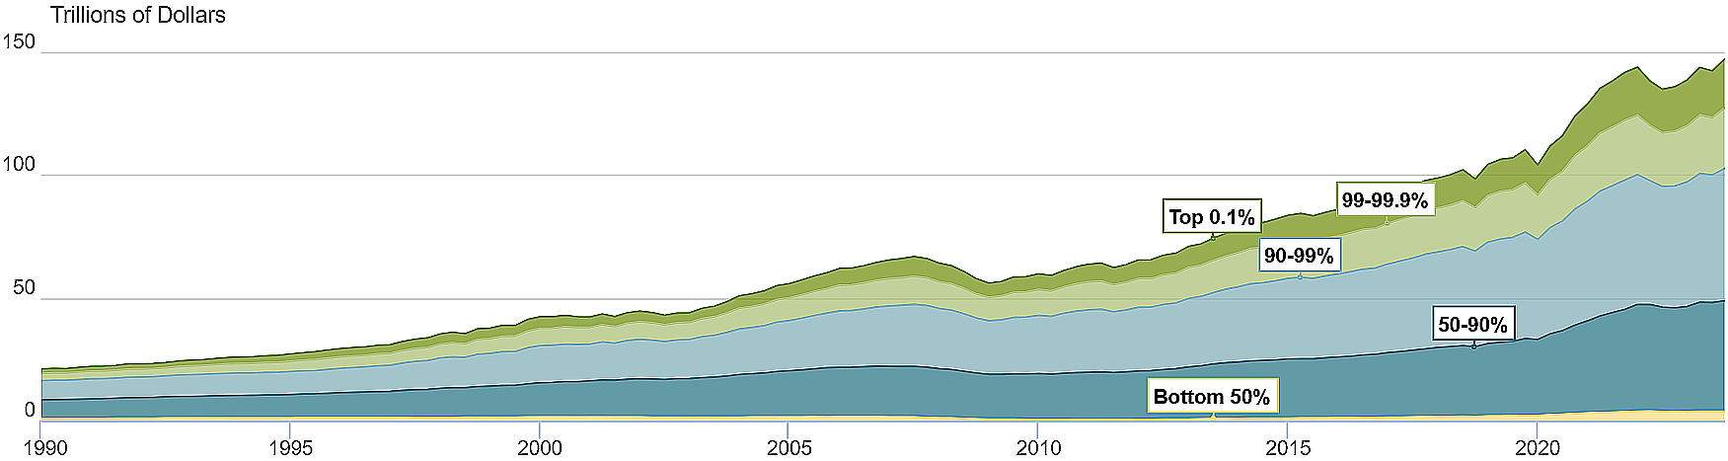

Notice that the bottom tier (bottom 50%) crawls along the bottom and barely lifts its head.

Capitalism’s inherent tendency toward wealth inequality is not confined to America. According to Credit Suisse Global Wealth (2022), which surveyed 5.4 billion people: 0.1% owns 25% of all wealth; 1% owns 43%; the bottom 50% owns less than 1%.

the solution

Capitalism provides enormous benefits: efficient allocation of capital and goods; lower prices through competition; a higher standard of living; innovation. But capitalism alone—laisse-faire capitalism—creates problems it cannot solve. Among these are: “class conflict between capital and labor”; “corruption and crony capitalism in the pursuit of profit”; “negative effects such as pollution”; “enormous wealth disparities and social inequalities.” To solve these problems, government intervention is required.

Government intervention need not result in socialism, if that is defined as state ownership of the means of production (land, capital goods like machinery, and the companies that use them to produce goods and services). But it tends toward socialism insofar as it takes some control of the economic system out of individuals’ hands and puts it in the hands of government.

Americans tolerate the government interventions that already exist: national parks (land unavailable to capitalists), minimum wages, tariffs, windfall taxes, estate taxes, inheritance taxes, license requirements, antitrust laws, eminent domain, the FDA, the EPA, etc. The US in fact owns 32 corporations. The US government redistributes wealth through progressive income taxes (1913), Social Security (1935), Medicare and Medicaid (1965), and Obamacare (2010). Yet Americans balk at further redistributions of the 76% of wealth that the 10% holds.

Let us not kill the goose that lays the golden eggs.
But let us distribute her golden eggs more equitably.

Censky, Annalyn. “How the Rich Became the Über Rich.” Money.CNN.com. 22 Feb. 2011. 28 Aug. 2011. <money.cnn. com/2011/02/22/news/economy/income_inequality/index.htm>.
Smith, Matthew, Owen Zidar, and Eric Zwick. “Top Wealth in America: New Estimates under Heterogeneous Returns.” Economics.Princeton.edu. Oct. 2021. 22 Oct. 2023. <economics.princeton.edu/work ing-papers/top-wealth-in-america-new-estimates-under-heterogenous-returns/#>.)
McGreal, Chris. “Angus Deaton on Inequality: “The War on Poverty Has Become a War on the Poor.”” The Guardian (7 Oct. 2023). <theguardian.com/inequality/2023/oct/07/angus-deaton-interview-book-economics-in-amer ica>.
“Most companies try to keep the cost of labor below 30% when taken as a percentage of sales.” (“What You Need to Know About Labor Cost Percentages.” Indeed.com. 2024. 12 May 2024. <indeed.com/hire/c/info/labor-cost-percentages>.)
Lu, Marcus. “Visualizing Wealth Distribution in America (1990-2023).” VisualCapitalist.com. 19 Feb. 2024. 21 May 2024. <visualcapitalist.com/wealth-distribution-in-america/>.
“Distribution of Household Wealth in the U.S. since 1989.” FederalReserve.gov. 22 Mar. 2024. 22 May 2024. <federalreserve.gov/releases/z1/dataviz/dfa/distribute/chart/#range:1989.4,2023.4>
The 0.1% is “175,000 ultra-wealthy people (those with over $50 million in net wealth) . . . the bottom 50 percent own only one percent.” (“Top 1 Percent of Households Own 43 Percent of Global Wealth.” TRT World. N.d. 22 May 2024. <trtworld.com/magazine/top-1-percent-of-households-own-43-percent-of-global-wealth-42134>.) “The wealthiest 1 percent of the world’s population now owns more than half of the world’s wealth . . .” (“Richest 1% Now Owns Half the World’s Wealth.” CNBC.com. 14 Nov. 2017. 12 May 2024. <cnbc.com/2017/11/14/richest-1-percent-now-own-half-the-worlds-wealth.html>.
Liberto, Daniel. “What Is Capitalism: Varieties, History, Pros and Cons, Socialism.” Investopedia.com. 8 May 2024.
“State-owned Enterprises of the United States.” Wikipedia. 8 Apr. 2024. 21 May 2024.
Not to mention 7 assistance programs overseen by the Social Security Administration: supplemental security income, temporary assistance for needy families, food and nutrition assistance, housing assistance, low-income home energy assistance, general assistance, and the earned income tax credit. (“Social Security Programs in the United States: Assistance Programs.” SSA.gov. N.d. 11 Jan. 2025. <ssa.gov/policy/docs/progdesc/sspus/assistance-programs.html>.)

