THE KA`BAH (KA`ABAH)

Paul Hahn, Theology Department
University of St Thomas, Houston TX 77006
© 2026, theologyplus.com

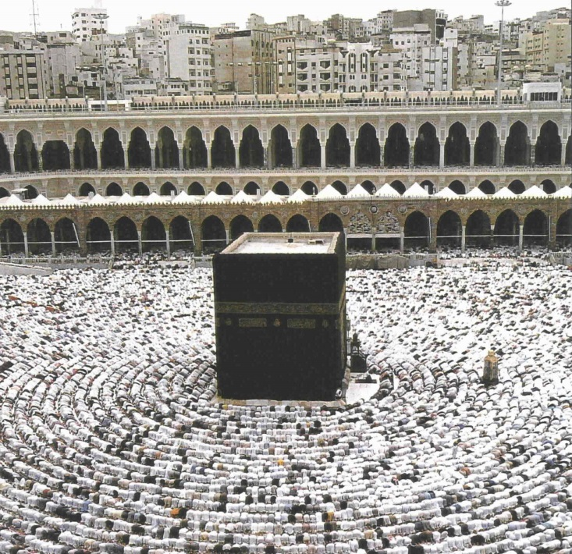

in general

“Ka`bah” is an Arabic word that literally means “cube.”
Actually it is about 43 feet in height by 43 feet in width by 38 feet in depth (13 meters × 11.5 meters × 13 meters).

It is the principal Muslim shrine.
It is called “the House of Allah.”
It—not the city of Mecca around it—is the qiblah, or point faced for daily ritual prayers (salat).
It is located directly below the heavenly ka`bah.

history

early
Its origin is unknown. It existed for several centuries before Muhammad (c. 570-632).
by the 500s CE
It had become central Arabia’s principal religious shrine.
It was at the center of a sacred territory (haram).
It had the characteristics of a Semitic sanctuary. (See “Haram.”)
630: Muhammad captures the ka`bah and empties it of idols.
The Qur’an says that every Muslim must make at least one pilgrimage there.
after Muhammad
Since the 600s, it has been damaged by fire, flood, earthquake, and attack.
One of the earliest builders was Abdullah (named by Muhammad), grandson of Abu Bakr (Muhammad’s best friend and, from 620 on, his father-in-law). (Ahmed 37)
the Umayyad dynasty (660-750)
The Umayyads rebuilt the ka`bah in gold. (Ahmed 37)
The caliph Al Walid (705-715), son of Abdul Malik, sent Byzantine architects, who tore down the old building and rebuilt an opulent ka`bah. (Ahmed 37)

medieval
“Later, Roman and Persian influences can be detected as distant caliphs sent their finest architects.” (Ahmed 37)

modern
Ottoman Empire (c. 1299-1922)
1500s: Sulayman the Magnificent (sultan from 1520-1566) sent the most renowned Muslim architect, Sinan, to improve it.
Since the 1600s, the ka`bah has had stones from earlier buildings.
1630: floods demolish the ka`bah (and the surrounding mosque). It is rebuilt in 1631.
The ka`bah is now at the center of the great open Haram Mosque.
1956: the Saudi government enlarged the Haram Mosque. It is now 175,732 square feet (16,326 square meters) and holds 300,000 people.
1958: the Saudi government repaired the walls and roof.

the present-day ka`bah

the building
It is made of granite.
It is 17+ yards (16+ meters) high, 14+ yards (13 meters) long, 12 yards (11 meters) wide.
There are no windows. A single door two meters above the pavement allows entry, but the ka`bah is rarely opened. Inside, 3 wood pillars support ceiling, gold and silver lamps suspend from the ceiling, and there are mobile stairs.

the black stone
It is of unknown pre-Islamic origin, possibly meteoric.
It fell from heaven or was brought by angels as an original white cornerstone.
It is in the east exterior corner. It is usually called “the cornerstone of the House,” or “the right hand of God on earth.”
It is now dark red-brown; darkened by human touch over centuries, it serves as a register of human degradation.
It is encased in a massive silver band.
It is not an idol: it is not worshiped.

the kiswah (“robe”)
This usually covers ka`bah.
It is made of thick embroidered cloth, black and gold.
It has wide bands of Arabic calligraphy, mostly Qur’anic verses.
before 1927: it was provided each year by Egypt, by pilgrimage caravan from Cairo.
now: it is made each year by Meccan artisans.

near the ka`bah
“the Station of Ibrahim” (Abraham)
A footprint of Ibrahim is preserved in stone (now in a gold cage).
Ibrahim supposedly stood there to finish constructing an earlier ka`bah.
“Zamzam” (sacred well)
It was supposedly made by God for Hajar (Hagar) and Isma`il (Ishmael) after commanding Ibrahim to abandon them (see Gen 16 and 21).
It is opposite the black stone, in a small building.
After circumambulations and prayers, pilgrims drink Zamzam’s water.

circumambulation rite (tawaf)

Circumambulation occurs during the pilgrimage season (the month of Ramadan).
Muslims circumambulate the ka`bah seven times (whether annual pilgrims or daily tourists).
At the beginning of the circumambulation rite, Muslims kiss or touch the Black Stone, as Muhammad supposedly did.
At the end of the circumambulation rite, Muslims press their bodies to the multazam (section of wall between the black stone and the raised door) to receive the ka`bah’s barakah (“blessing,” “power”).

bibliography

Ahmed, Akbar S. Discovering Islam: Making Sense of Muslim History and Society. London: Routledge and Kegan Paul, 1988.

“Haram.” Wikipedia. 13 Oct. 2025. 17 Oct. 2025. <en.wikipedia.org/wiki/Haram >.

