THE CHI RHO SYMBOL

Paul Hahn, Theology Department
University of St Thomas, Houston
© 2026, theologyplus.com
All scripture quotations are from the New Revised Standard Version updated edition.

In the Old Testament, the Hebrew word מָשִׁיחַ (mashiakh, “messiah”) occurs about 50 times. It means “anointed one” (one who is anointed with olive oil). Three types of person were anointed in the Old Testament: kings, at coronations; priests, at ordinations; and prophets. There is also reference to a special anointed one (messiah) who will arrive in the future, someone who will bring salvation.

In the New Testament, Jesus is referred to as the messiah 531 times. The Greek word for “anointed (one)” is χριστός, christos. (In English, the word for the consecrated [blessed] oil in baptisms and other rites is “chrism.” Chrism is oil plus balsam, aromatic plant resin.)

The first two letters of Christos in Greek (χ, chi, and ρ, rho), if superimposed, look like this:

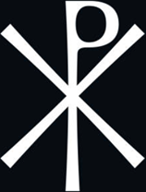

This symbol is called a “chi rho.” It emphasizes that Jesus was crucified, since the top of the letter rho looks like a head and the letter chi is like a cross.

In Rev 22:13, the resurrected Jesus says, “I am the Alpha and the Omega, the First and the Last, the Beginning and the End.” The first and last letters of the Greek alphabet, alpha (α, Α) and omega (ω, Ω), if added to the superimposed letters above, look like this:

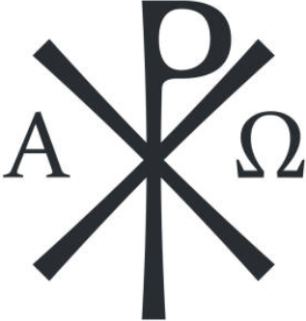

This version of the chi rho emphasizes that Jesus, though crucified, remains eternal.

