THE TWELVE TRIBES OF ISRAEL

Paul Hahn, Theology Department
University of St Thomas, Houston TX 77006
© 2026, theologyplus.com
All scripture quotations are from the New Revised Standard Version updated edition.

Genesis has two main divisions: Gen 1-11, the primitive history (quasi-mythological tales such as creation, Adam and Eve, Noah, and the Tower of Babel); and Gen 12-50, the patriarchal narratives (stories about Abraham, Isaac, Jacob, and Jacob’s twelve sons).

In one story, Jacob is attacked by and wrestles with a mysterious stranger (perhaps an angel or God). The stranger renames Jacob (Gen 32:28): “You shall no longer be called Jacob, but Israel, for you have striven with God and with humans and have prevailed.” (“Israel” is from two Hebrew words, sara he fought + ´El God.) Consequently, Jacob’s sons were known as the twelve tribes of Israel; and all of his progeny were known as the nation of Israel. (A self-deprecating name: Israel as a nation is a contentious bunch; they wrestle with God!)

Jacob fathered his 12 sons with his 2 wives, Leah and Rachel, and their 2 slaves, Zilpah (Leah’s handmaid) and Bilhah (Rachel’s handmaid). Numbers indicate birth order.

Jacob ┬ Leah (wife)
1 Reuben
2 Simeon
3 Levi
4 Judah
9 Issachar
10 Zebulun

Jacob ┬ Bilhah (concubine)
5 Dan
6 Naphtali

Jacob ┬ Zilpah (concubine)
7 Gad
8 Asher

Jacob ┬ Rachel (wife)
11 Joseph
12 Benjamin

After leaving Egypt, wandering in the wilderness, and entering the Promised Land (Exodus-Josh 12), the 12 tribes settled down. Here is a map of their territories, according to Josh 13-21.

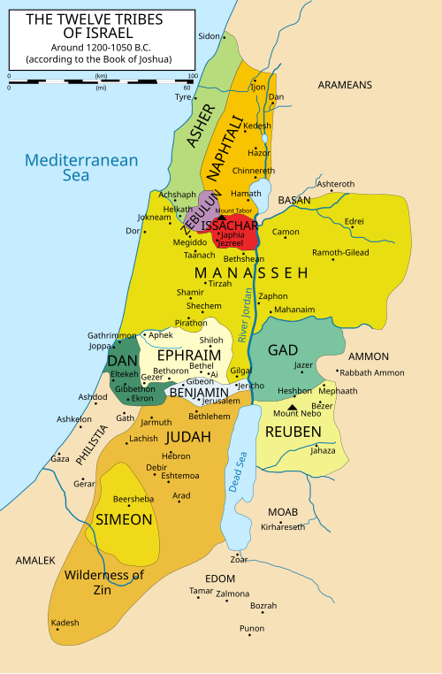
“12 Tribes of Israel Map.” Wikimedia Commons. 24 July 2024. 9 Oct. 2025
<commons.wikimedia.org/wiki/File:12_Tribes_of_Israel_Map.svg>.

