TRICKLE-DOWN ECONOMICS

Paul Hahn, Theology Department
University of St Thomas, Houston TX 77006
© 2026, theologyplus.com

Clarke, Kevin. “Can Christian Economics Promote a Trickle-Up Effect?” USCatholic.org. 5 Mar. 2021. 22 Mar. 2021. Web.
Kent, Ana, Lowell Ricketts, and Ray Boshara. “What Wealth Inequality in America Looks Like: Key Facts & Figures.” StLouisFed.org. 14 Aug. 2019. 25 Mar. 2021. Web.
Krugman, Paul. “The Incredible Disappearing Tax Cut.” NYTimes.com. 23 Mar. 2021. 24 Mar. 2021. Web.
Stirling, Craig. “Fifty Years of Tax Cuts for Rich Didn’t Trickle Down, Study Says.” Bloomberg News. 16 Dec. 2020.
“Wealth Inequality in the United States” Wikipedia. 10 Oct. 2021. 12 Oct. 2021. Web.

Here is an interesting observation concerning trickle-down economics:

A study from the London School of Economics reviewed 50 years of data from 18 member states of the Organisation of Economic Cooperation and Development (OECD), a who’s who of the world’s advanced economies. Although so-called tax reforms differed in each country, researchers found that beginning in the 1960s through the 1990s policy in these wealthy nations converged to represent a 30 percent reduction in taxes for the wealthiest. If trickle-down economics worked, that write-off should have had a meaningful impact on the standard of living for all citizens in these OECD states. Instead researchers concluded that economic performance, as measured by real per capita GDP and the unemployment rate, was “not significantly affected by major tax cuts for the rich.” In fact, they discovered that tax cuts at the top created little more than historic levels of economic inequality . . . (Clarke) (For the study by the London School of Economics, see Stirling.)

And here are data from the St Louis Federal Reserve on the growth of wealth inequality from 1989 to 2016. (Kent) Notice that these are data from prior to President Donald Trump’s tax cuts—which we can expect have exacerbated the inequality further.

total U.S. wealth:

1989 (93 million families)
top 10% of families 67%
middle 50%-90% of families 30%
bottom 50% of families 3%

2016 (126 million families)
top 10% of families 77%
middle 50%-90% of families 22%
bottom 50% of families 1%

The St Louis Federal Reserve goes on to say:

Wealth inequality in America has grown tremendously from 1989 to 2016, to the point where the top 10% of families ranked by household wealth (with at least $1.2 million in net worth) own 77% of the wealth “pie.” The bottom half of families ranked by household wealth (with $97,000 or less in net worth) own only 1% of the pie. So, even though the total wealth pie grew, this rising economic tide did not lift all boats. On average, the bottom half of Americans are getting left behind. (Kent)

Here is a chart from the St Louis Fed (taken from “Wealth Inequality in the United States” in Wikipedia, 10 Oct. 2021). Notice the line for the “Bottom 50 Percent”: it has stayed almost level and even declined a bit for the quarter of a century during it was promised that tax cuts for the rich would to benefit the poor.

Holdings of Family Wealth (Trillions of 2013 Dollars)
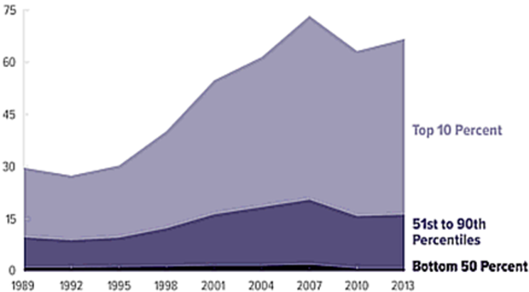

Here is the assessment of Paul Krugman, Nobel Prize-winning economist, of the Trump tax cuts’ effects:

. . . these days you hardly ever hear people talking about the Tax Cut and Jobs Act, enacted in December 2017. . . . [That] tax cut didn’t deliver what it promised: a big surge in business investment. What it did deliver was a big windfall, not just to the wealthy, but to wealthy foreigners. Not something they want to highlight.
The core of the Tax Cut and Jobs Act was a big slash in the tax rate on corporate profits. This was supposed to make investing in the United States much more attractive, drawing in money that would otherwise have been invested abroad. And as companies expanded their U.S. operations, they would need more workers, raising the demand for labor, and hence driving up wages. So the claim was that what looked on the surface like a big tax cut for wealthy stockholders was really going to go mainly to workers.
But the promised investment surge never arrived. It turned out that while U.S. corporations appeared, on paper, to have big investments overseas, many of those assets were basically fictitious: companies had been juggling the books to report big profits in low-tax jurisdictions like Ireland, which made it look as if they were investing a lot of capital there, but that didn’t mean they were really building a lot of factories or buying a lot of equipment. So there wasn’t actually a big hoard of capital ready to return if taxes were cut, and the big tax cut did basically nothing for business investment in America.
What that meant in turn was that what looked on the surface like a big tax cut for wealthy stockholders—who are, after all, the ultimate beneficiaries of after-tax corporate profits—was, in fact, a big tax cut for wealthy stockholders. (Krugman)

