SACRAMENTAL GRACES

Paul Hahn, Theology Department

University of St Thomas, Houston 77006

© 2022

“Repeal Vatican Mass Rule Pleads Cardinal Sarah.” *TheTablet*.*co*.*uk*. 29 Mar. 2021. 29 Mar. 2021. Web.

Recently the Congregation for the Doctrine of the Faith (CDF) produced a document that reduces the number of Masses priests can say by themselves. The reduction took effect on March 22.

Since Masses said by priests alone (plus an altar server) were more common prior to Vatican II than after, in part the CDF ruling has to do with traditionalists vs. progressives. (See “Repeal.”)

Sounds to me like a tempest in a side chapel.

Criticizing the CDF document, Cardinal Sarah said that increasing Masses increases grace. I disagree. Sacramental graces exist, and they differ according to the sacrament in question. The sacraments are indeed channels of “guaranteed graces”; that’s what makes them sacraments. God has promised that from these rituals certain graces will flow. But I strongly doubt a one-to-one correspondence between amount of Masses and amount of Eucharistic sacramental graces. There are also non-sacramental graces, graces given throughout each individual’s day in the context of his or her daily life. God is free to send graces whenever and to whomever he wishes, of whatever type and in whatever strength he wishes, be they tied to a sacrament or not.

In a tweet on the CDF’s ruling, Theodora Hawksley wrote, “It is acherly [actually] much worse than this as the science shows.” She presents the “science” in a chart:

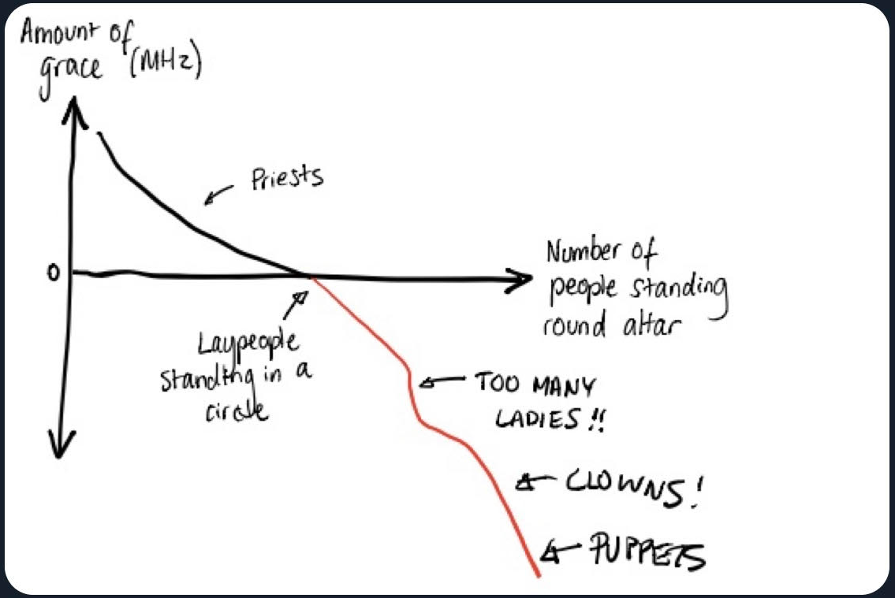

The chart spoofs exactly what needs to be spoofed: the idea that grace can be “quantified.”